 | PRODUCT SPECIFICATION
TAP304KCP-Kolt Bath Filler Chrome
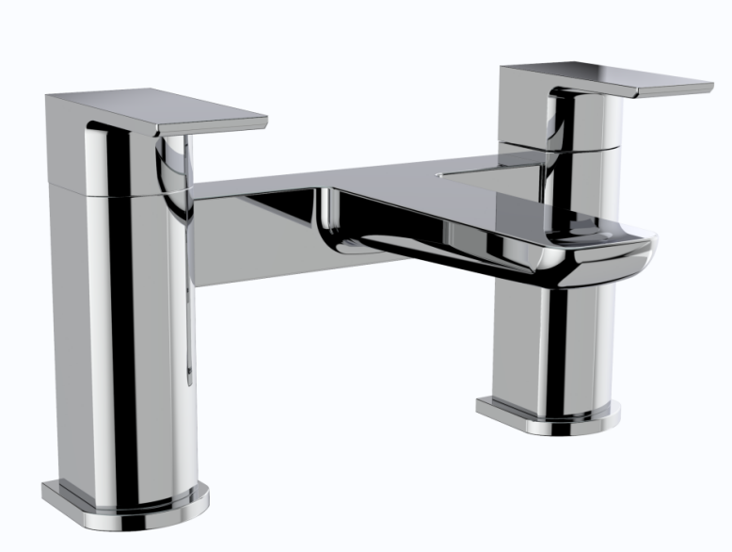 |  | BAR CODE: 5055681461225  COLOUR: CHROME  WEIGHT:  NET 2.13 kg (tap only)  GROSS 2.45 kg  STANDARDS: BS EN 200 NOTES: SUITABLE FOR PRESSURES BETWEEN 0.5-10BAR Flow Rate:
  0 . 2 bar | 0 . 5 bar | 1 bar | 2 bar | 3 bar
  9.7 L | 17.3 L | 25.2L | 35.5L | 44.1 L
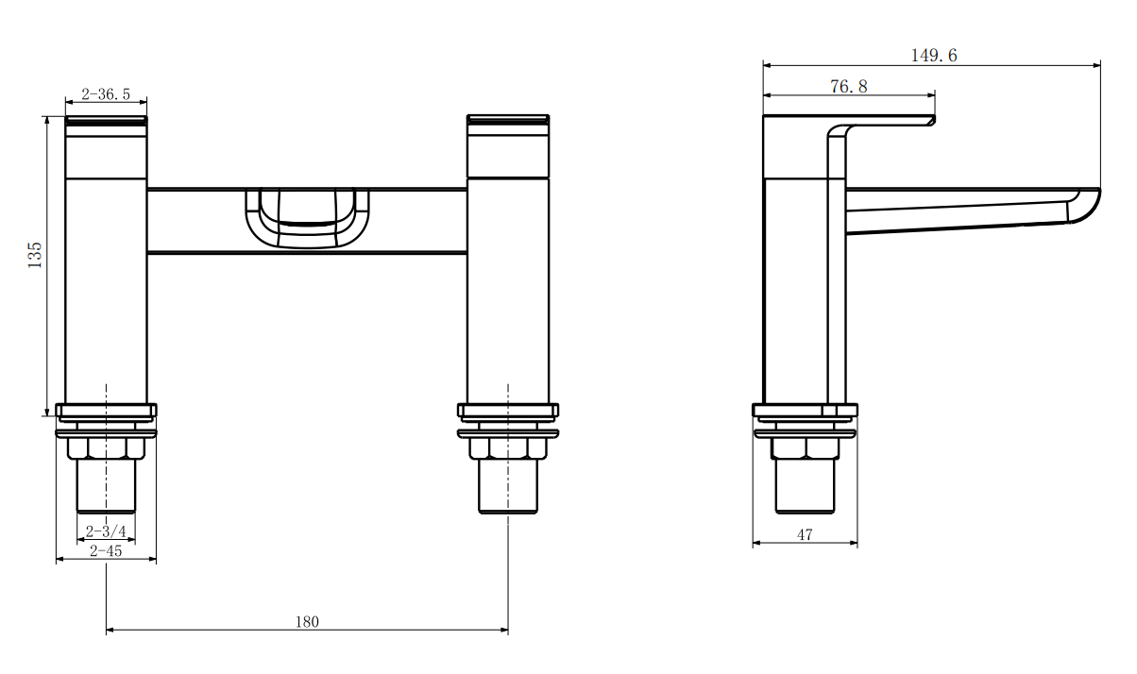
BOX SIZE 240X160X187

