 | PRODUCT SPECIFICATION
TAP310KBL-Kolt Mono Basin Mixer Matt Black
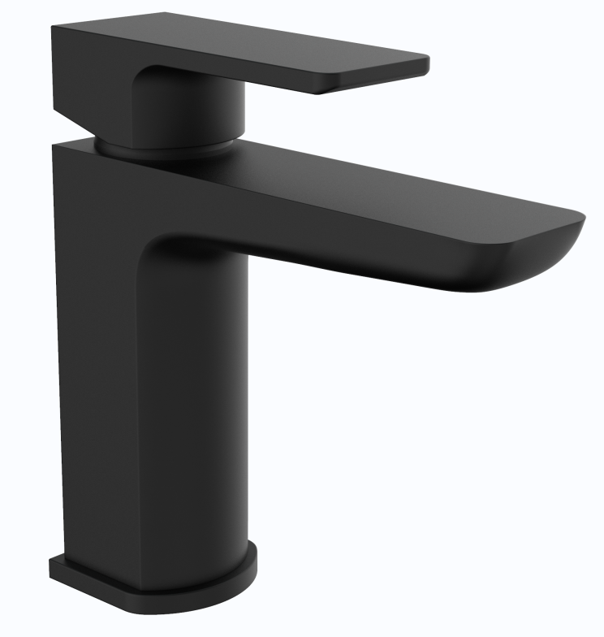 |  | BAR CODE: 5055681461270  COLOUR: MATT-BLACK  WEIGHT:  NET 1.18 kg (tap only)  GROSS 1.62 kg  STANDARDS: BS EN 200 NOTES: SUITABLE FOR PRESSURES BETWEEN 0.5-10BAR Flow Rate:
  0 . 2 bar | 0 . 5 bar | 1 bar | 2 bar | 3 bar
  4.4 L | 8.2 L | 11.8 L | 17.1L | 20.8 L
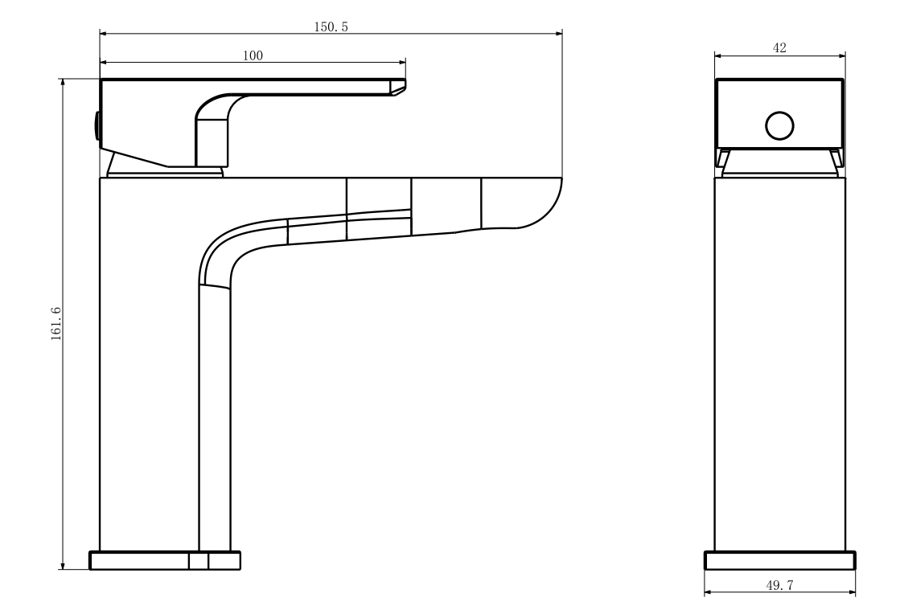
BOX SIZE 175X159X77

