 | PRODUCT SPECIFICATION
TAP311KBL-Kolt Hi-Rise Mono Basin Mixer Matt Black
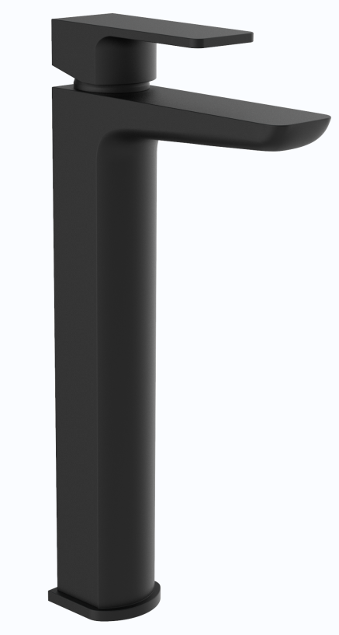 |  | BAR CODE: 5055681461287  COLOUR: MATT-BLACK  WEIGHT:  NET 1.57 kg (tap only)  GROSS 1.91 kg  STANDARDS: BS EN 200 NOTES: SUITABLE FOR PRESSURES BETWEEN 0.5-10BAR Flow Rate:
  0 . 2 bar | 0 . 5 bar | 1 bar | 2 bar | 3 bar
  4.4 L | 7.8L | 11.4 L | 16.4L | 20.1 L
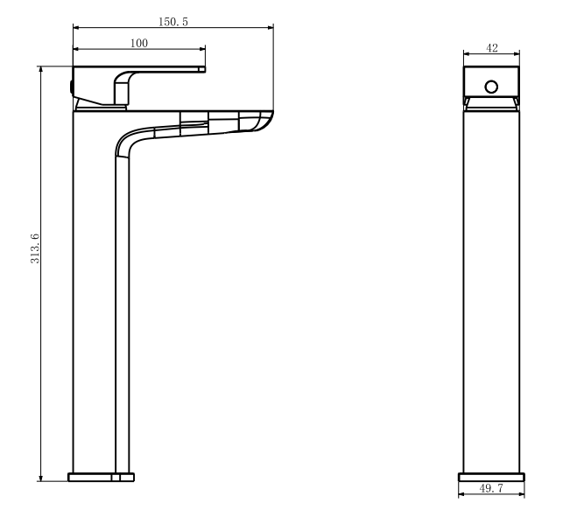
BOX SIZE 351X148X60

