 | PRODUCT SPECIFICATION
TAP315KBL-Kolt Bath Shower Mixer Matt Black
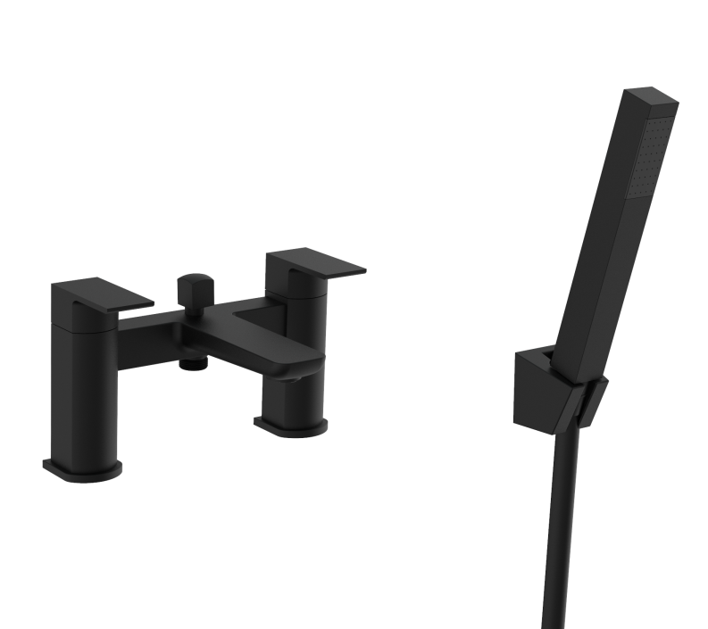 |  | BAR CODE: 5055681461317  COLOUR: MATT-BLACK  WEIGHT:  NET 2.7 kg (tap only)  GROSS 3.04 kg  STANDARDS: BS EN 200 NOTES: SUITABLE FOR PRESSURES BETWEEN 0.5-10BAR Flow Rate:
  0 . 2 bar | 0 . 5 bar | 1 bar | 2 bar | 3 bar
  9 L | 16.5 L | 24.3 L | 34.2L | 43.2 L
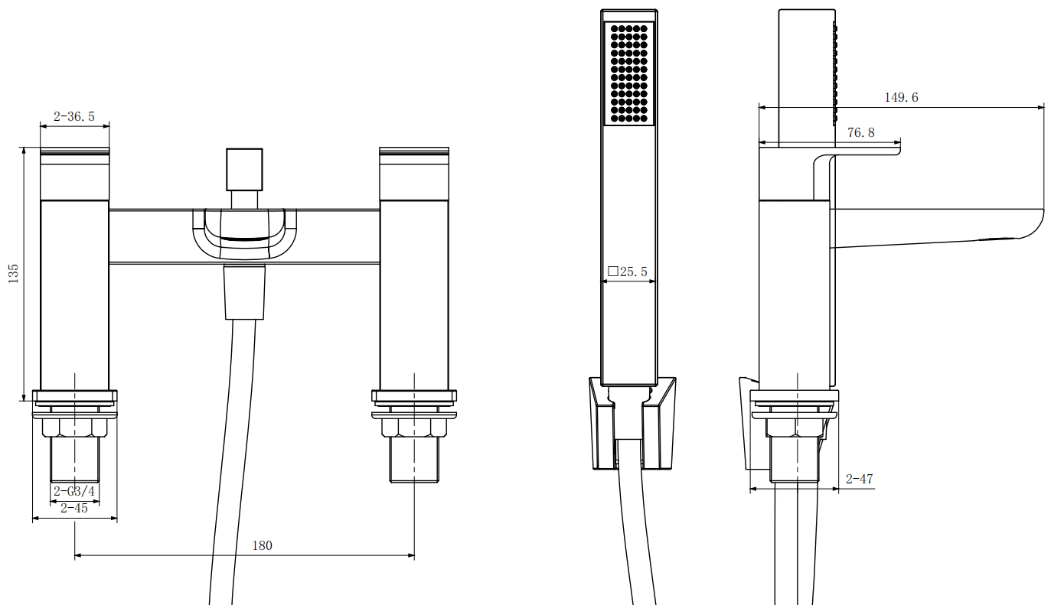
BOX SIZE 240X160X187

