 | PRODUCT SPECIFICATION
TAP332KBN-Kolt Mini Mono Basin Mixer Brushed Nickel
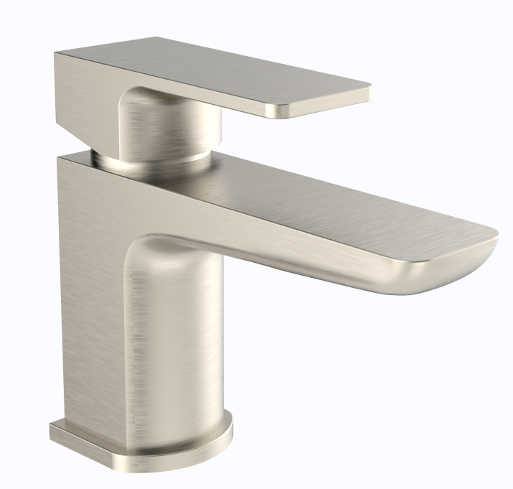 |  | BAR CODE: 5055681461454  COLOUR: Brushed Nickel  WEIGHT:  NET 1.16 kg (tap only)  GROSS 1.53 kg  STANDARDS: BS EN 200 NOTES: SUITABLE FOR PRESSURES BETWEEN 0.5-10BAR Flow Rate:
  0 . 2 bar | 0 . 5 bar | 1 bar | 2 bar | 3 bar
  4.5 L | 8.1L | 12 L | 17.3L | 21 L
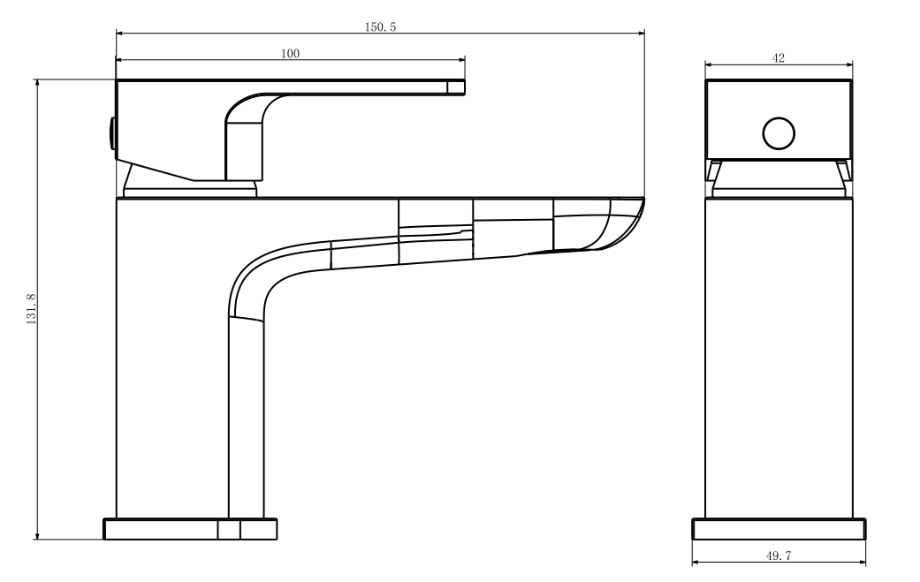
BOX SIZE 175X159X77

